**WEB SCRAPING AND RESEARCH AUTOMATION**

**A summer internship 2 report submitted in partial fulfilment of the requirements for the award of degree of**

**BACHELOR OF TECHNOLOGY IN**

**COMPUTER SCIENCE AND ENGINEERING**

**Submitted by**

**Kamuju Vinay HU21CSEN0300505**

**Under the guidance of**

**Dr. U. Srinivasarao Assistant Professor**



**Department of Computer Science and Engineering**

**GITAM School of Technology**

**GITAM Deemed to be University Hyderabad Campus -502329**

**July- 2024**

**GANDHI INSTITUTE OF TECHNOLOGY AND MANAGEMENT (GITAM)**

**(Declared as Deemed-to-be-University u/s 3 of UGC Act 1956) HYDERABAD CAMPUS**



**DECLARATION**

I hereby declare that the summer internship report entitled **“WEB SCRAPING AND RESEARCH AUTOMATION”** is an original work done in the Department of Computer Science and Engineering, GITAM School of Technology, GITAM (Deemed to be University) submitted in partial fulfilment of the requirements for the award of the degree of “Bachelor of Technology” in Computer Science and Engineering. The work had not been submitted to any other college or university for the award of any degree or diploma.

Place – HYDERABAD Kamuju Vinay

Date-12-08-2024 HU21CSEN0300505

**DEPARTMENT OF COMPUTER SCIENCE AND ENGINEERING GITAM SCHOOL OF TECHNOLOGY**

**GITAM (DEEMED TO BE UNIVERSITY) HYDERABAD CAMPUS**



**CERTIFICATE**

This is to certify that the Internship report entitled **“WEB SCRAPING AND RESEARCH AND AUTOMATION”** is a bonafide record of work carried out by **KAMUJU VINAY (HU21CSEN0300505)** submitted in partial fulfillment of the requirement for the award of the degree of Bachelors of Technology in Computer Science and Engineering.



**Dr. U. Srinivasarao Dr. Mahaboob Basha Shaik**

Assistant Professor Professor & HOD

Dept. of CS

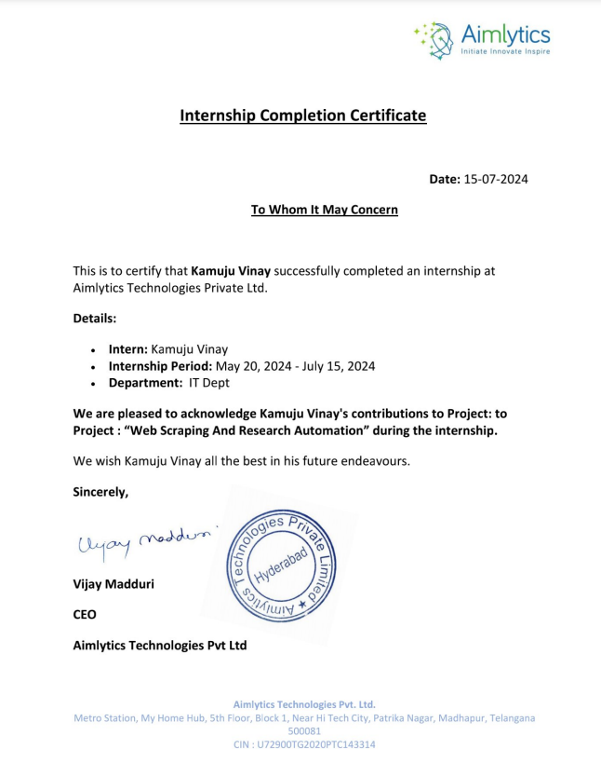

**ACKNOWLEDGEMENT**

Apart from my effort, the success of this Internship-2 largely depends on the encouragement and guidance of many others. I take this opportunity to express my gratitude to the people who have helped me in the successful competition of this Internship-2.

I would like to thank respected **Prof. D. Sambasiva Rao**, Pro Vice Chancellor, GITAM Hyderabad, and **Dr. N. Seetharamaiah**, Associate Director, GITAM Hyderabad.

I would like to thank respected **Dr. Mahaboob Shaik Basha,** Head of the Computer Science and Engineering for giving me such a wonderful opportunity to expand my knowledge for my own branch and giving me guidelines to present an Internship- 2 report. It helped me a lot to realize of what we study for.

I would like to thank the respected faculties **Mr. Dr. U. Srinivasarao** who helped me to make this Internship-2 a successful accomplishment.

I would also like to thank my friends who helped me to make my work more organized and well-stacked till the end.

Name: KAMUJU VINAY

Pin: HU21CSEN0300505

**ABSTRACT**

In the evolving field of Generative AI, the development of advanced tools to automate web scraping has gained significant momentum. This internship project, "Web Scraping and Research Automation," represents a cutting-edge application leveraging Generative AI to revolutionize the way users extract and interact with web-based information. The system is designed to autonomously gather and process data from provided URLs, offering concise summaries and detailed insights into the extracted content.

This abstract outline the core functionalities of "Web Scraping Automation," which utilizes advanced Generative AI techniques to analyze and interpret diverse web data. The application employs sophisticated NLP algorithms to generate summaries that encapsulate the essence of the content, while also performing entity recognition and data extraction to provide users with actionable insights.

The discussion includes an exploration of the underlying architecture and components of the system, highlighting its ability to streamline data collection and analysis processes. By focusing on automation and intelligent content extraction, the application enhances data accessibility and usability, addressing the needs of users seeking efficient ways to engage with and understand complex web-based information.

The abstract further delves into the technical challenges associated with the project, such as ensuring the accuracy of data extraction and the reliability of automated processes. It also considers the practical implications of integrating Generative AI into web scraping tools, including potential benefits for businesses, researchers, and content professionals.

As the field of Generative AI continues to advance, "Web Scraping Automation" stands out as a pioneering solution that exemplifies the potential of AI-driven data analysis. This abstract provides an overview of the application's contributions to improving data accessibility and understanding, positioning it as a valuable tool in the evolving landscape of digital content interaction.

**WEB SCRAPING AND RESEARCH AUTOMATION**

|  |  |  |
| --- | --- | --- |
| CHA | Table of Contents | Page No |
| 1 | 1. Introduction | **8-9** |
|  | 1.1 Over view of Internship | 8 |
|  | 1.2 Objectives and Goals | 9 |
| 2 | 1. LangChain | **9-16** |
|  | 2.1 Introduction to LangChain | 9 |
|  | 2.2 LLM Chain | 10 |
|  | 2.3 Retrieval Chain | 11- 12 |
|  | 2.4 Prompt Template | 12-14 |
|  | 2.5 Output Parser | 14 |
|  | 2.6 Agents | 15-16 |
| 3 | 1. API | **16-17** |
|  | * 1. Introduction to Cohere API | 16 |
|  | * 1. Embedding Generation | 16 |
|  | * 1. Language Models | 17 |
|  | 3.4 API Integration | 17 |
| 4 | 1. Web Scraping | **17-19** |
|  | * 1. Introduction to Beautiful Soup | 17 |
|  | 4.2 HTML Parsing | 18 |
|  | 4.3 HTML Parsing | 18 |
|  | 4.4 Integration with LangChain | 19 |
| 5 | 1. Elasticsearch Database | **19-22** |
|  | * 1. Introduction to Elasticsearch | 19 |
|  | * 1. Indexing Documents | 21 |
|  | * 1. Search and Retrieval | 21 |
|  | 5.4 Integration with LangChain | 22 |
| 6 | 1. Final Project Overview | **22-26** |
|  | * 1. Project Description | 22 |
|  | * 1. System Architecture | 23 |
|  | * 1. Code Implementation | 24-26 |
|  | * 1. Results and Observations | 26 |
| 7 | 1. Path Forward and Future Enhancements | **26-28** |
|  | 7.1 Summary of Learnings | 26-27 |
|  | * 1. Future Work and Improvements | 27-28 |
| 8 | 1. Conclusion | **29** |

**Chapter 1. Introduction**

**1.1 Overview of Internship**

During my internship, I worked on a project focused on creating an advanced natural language processing

(NLP) system. This project involved the integration of various cutting-edge technologies, including

LangChain, the Cohere API, Beautiful Soup for web scraping, and Elasticsearch for data storage and retrieval.

The goal was to build a comprehensive pipeline capable of extracting information from web pages processing

the text, and generating relevant responses to user queries. This internship provided me with hands-on

experience and deepened my understanding of these technologies and their practical applications.

**1.2 Objectives and Goals**

The main objectives and goals of my internship were:

1. **Mastering LangChain:**

* Understanding the LangChain framework and its components.
* Building and optimizing NLP pipelines using LangChain.

1. **Utilizing the Cohere API:**

* Generating text embeddings using the Cohere API.
* Integrating Cohere’s language models for various NLP tasks.

1. **Developing Web Scraping Skills with Beautiful Soup:**

* Extracting data from web pages using Beautiful Soup.
* Cleaning and processing HTML content for further analysis.

1. **Leveraging Elasticsearch for Data Storage and Retrieval**:

* Setting up and configuring Elasticsearch to store text embeddings
* Performing efficient search and retrieval operations on stored data.

1. **Building a Comprehensive NLP pipeline:**

* Combining all learned technologies to create an end-to-end system.
* Ensuring the pipeline can handle user queries and generate accurate responses

1. **Delivering of the Final Project**

* Developing a project showcasing the integration of all technologies.
* Demonstrating the system’s ability to interact with web content and respond to user queries effectively.

**Chapter 2. LangChain**

**2.1 Introduction to LangChain**

LangChain is a powerful framework designed to simplify the development of natural language processing (NLP) applications by providing a unified interface for building and managing complex NLP pipelines. It allows developers to easily integrate various NLP components, such as language models, retrievers, prompt templates, and output parsers, into a cohesive system. LangChain is particularly useful for tasks that require chaining together multiple NLP operations, enabling seamless data flow and efficient processing.

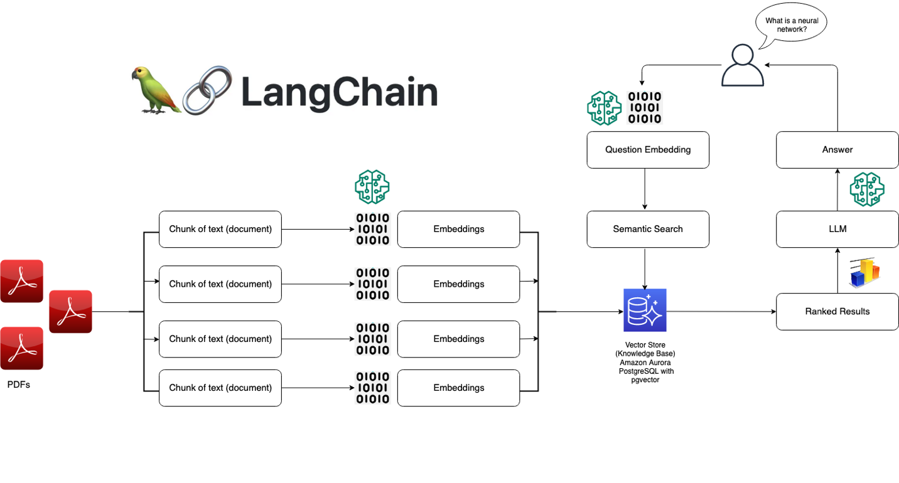

**Applications of Lang Chain**

LangChain can be applied in various domains, such as creating conversational AI agents that interact with users and perform tasks using natural language, developing document understanding and summarization tools to extract key information from lengthy texts, and building automated research assistants capable of gathering, summarizing, and presenting insights from web sources. Additionally, LangChain can be utilized for content generation, enabling the automated creation of articles, reports, or creative writing based on specific prompts, thus streamlining the content creation process.

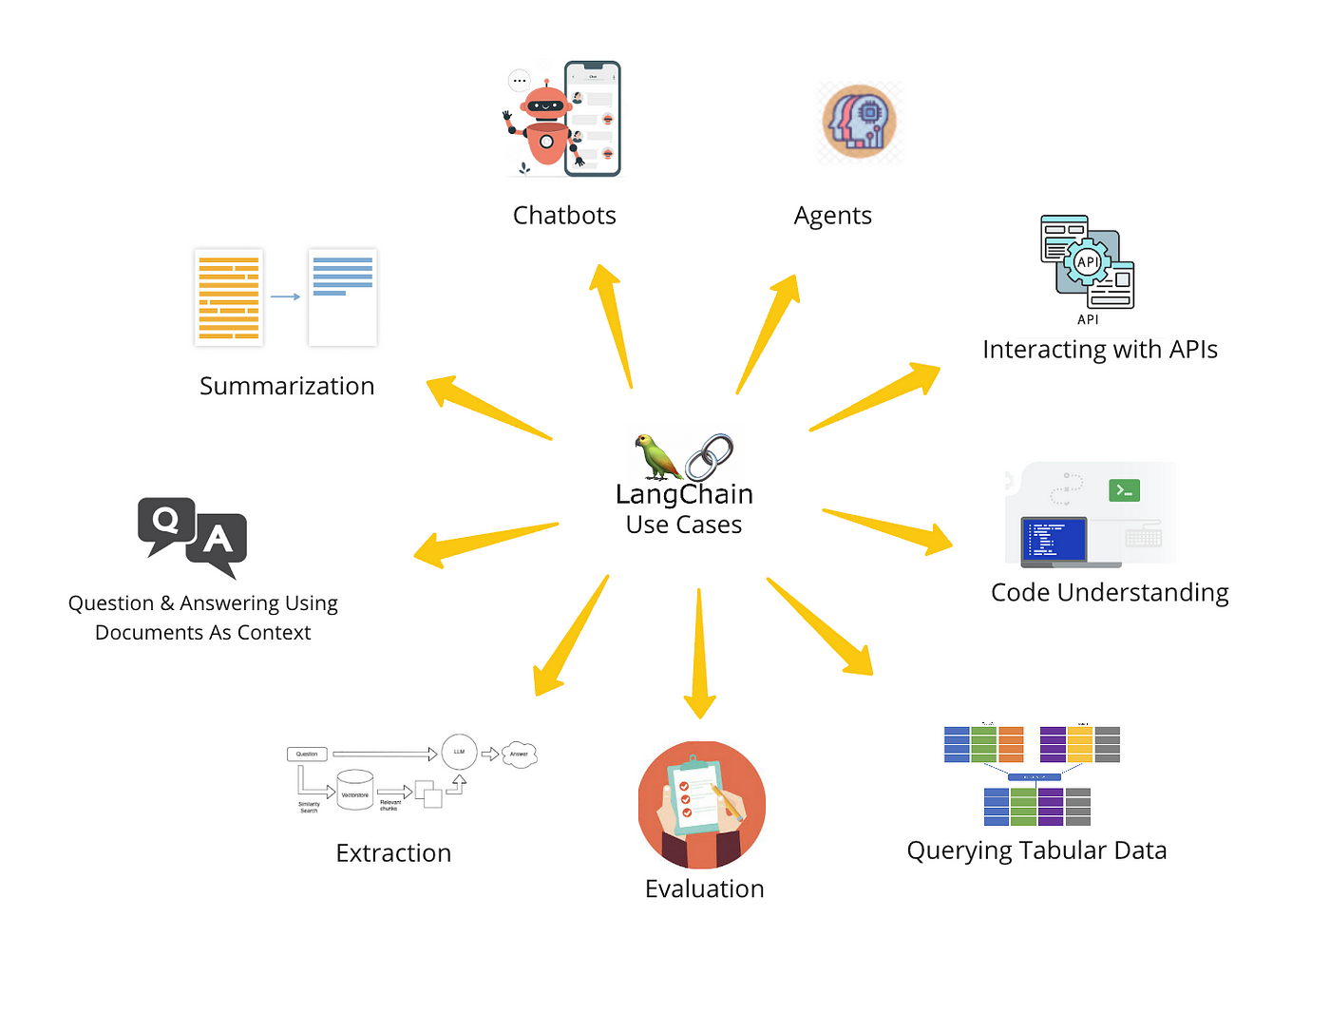

**2.2 LLMChain**

LLMChain is a component of LangChain that focuses on leveraging large language models (LLMs) for various NLP tasks. It allows for the integration of pre-trained language models, such as those provided by Cohere or OpenAI, into the LangChain pipeline. LLMChain is designed to handle tasks like text generation, summarization, and question answering, making it a versatile tool for building sophisticated NLP applications.

**Key Features:**

* Seamless Integration: Easily integrate pre-trained language models into your pipeline.
* Flexible Configuration: Configure LLMs for different tasks and use cases.
* High-Quality Output: Generate accurate and contextually relevant text based on input prompts.

**Uses of LLM Chain**

The LLM (Large Language Model) chain in LangChain is highly versatile, enabling complex task automation by linking multiple prompts together, which allows for sophisticated interactions and decision-making. It can handle advanced queries by breaking them down into smaller, manageable parts, ensuring accurate and comprehensive responses. Additionally, LLM chains facilitate context management across conversations, helping to maintain coherence and relevance in ongoing dialogues. This makes them particularly useful for developing intelligent systems that require a deep understanding of context and the ability to perform nuanced tasks.

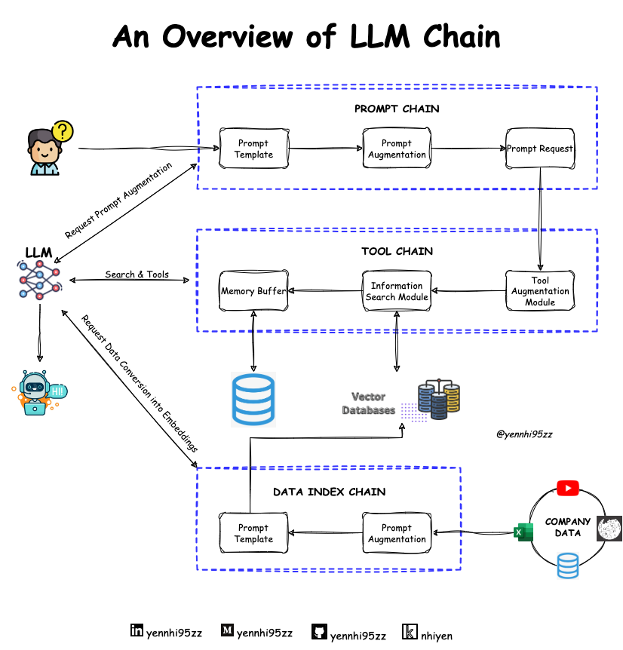

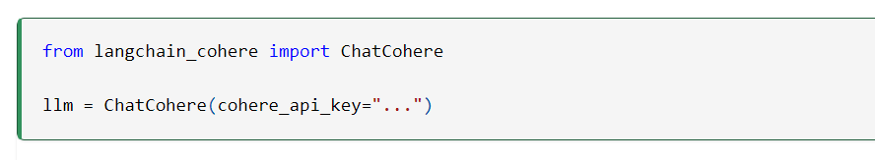

**2.3 Retrieval Chain**

Retrieval Chain is another core component of LangChain, designed to handle the retrieval of relevant documents or information based on user queries. It utilizes advanced search and retrieval techniques to fetch data from various sources, such as databases, web pages, or document stores. Retrieval Chain ensures that the pipeline can provide accurate and relevant responses by leveraging efficient indexing and search mechanisms.

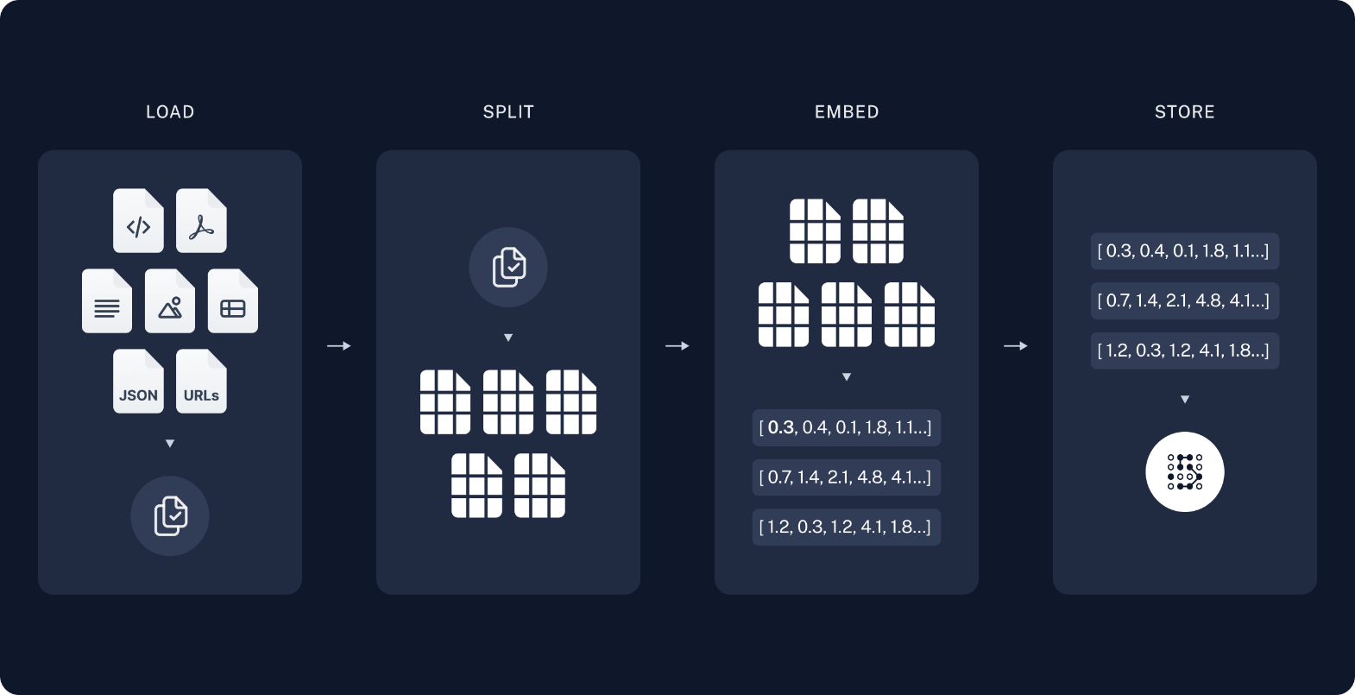

**Key Features:**

* Efficient Search: Quickly retrieve relevant documents based on user queries.
* Scalable Indexing: Handle large volumes of data with scalable indexing solutions.
* Customizable Retrieval: Configure retrieval parameters to suit specific use cases and data sources.

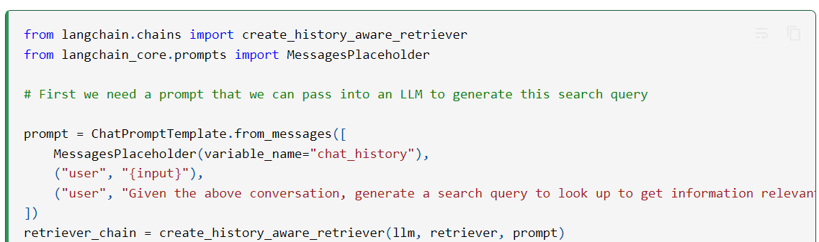

**Application of the Retrieval Chain**

The retrieval chain is crucial in various applications that require efficient access to relevant information. In question answering systems, it quickly retrieves pertinent data or documents from extensive datasets, ensuring that users receive accurate and contextually relevant answers. In document management, the retrieval chain helps in organizing and accessing specific information from large collections, facilitating easier navigation and retrieval of key details. It also plays a significant role in content recommendation systems, where it fetches and suggests relevant content based on user preferencesand query context, thereby enhancing user experience and engagement.

**2.4 Prompt Templates**

Prompt templates in LangChain are used to guide language models in generating contextually relevant responses. These templates define the structure and format of the prompts provided to the language model, ensuring that the generated text aligns with the desired output. Prompt templates can be customized to suit different tasks and applications, making them a crucial part of the pipeline.

**Key Features:**

* Customizable Structure: Define the format and content of prompts for different tasks.
* Consistent Output: Ensure that language models generate text that aligns with the specified format.
* Task-Specific Templates: Create templates tailored to specific NLP tasks, such as summarization or question answering.

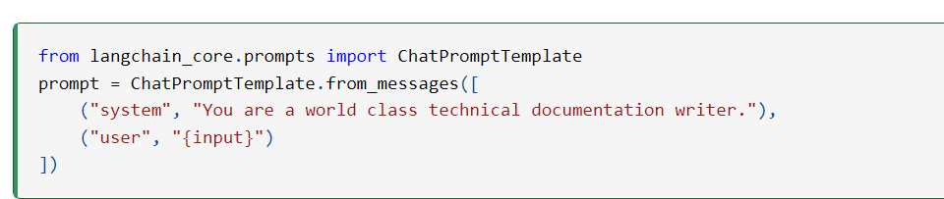

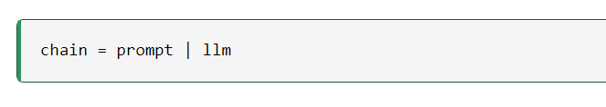

**Uses of prompt Template**

Prompt templates are highly beneficial in various applications by enhancing consistency and accuracy in interactions with language models. They facilitate standardized responses, ensuring uniformity across similar queries, which is crucial for applications like customer support and automated feedback systems. By structuring prompts in a specific way, these templates guide the language model to generate more precise and contextually relevant answers, improving performance in complex or specialized domains. Additionally, prompt templates increase efficiency by providing a reusable framework for prompt creation, saving time and effort. They are also valuable in training and fine-tuning models, offering consistent examples that help the model learn how to handle diverse inputs effectively. Moreover, prompt templates enable customizable interactions, allowing adjustments based on user needs or application requirements, thereby enhancing the overall user experience.

**2.5 Output Parsers**

Output parsers in LangChain are responsible for interpreting and formatting the responses generated by language models. They ensure that the output is usable and relevant to the user’s query, converting raw text into structured and meaningful information. Output parsers play a critical role in maintaining the quality and consistency of the pipeline’s output.

**Key Features:**

* Structured Output: Convert raw text into structured and meaningful information.
* Consistent Formatting: Ensure that output aligns with the specified format and requirements.
* Error Handling: Handle errors and inconsistencies in the generated text to maintain output quality.

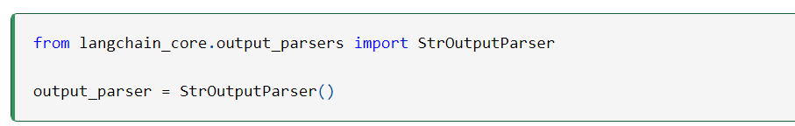

**2.6 Agents**

Agents in LangChain manage the flow of data through the pipeline, ensuring that each step is executed correctly and efficiently. They coordinate the various components, such as language models, retrievers, and parsers, to create a seamless and integrated NLP system. Agents are essential for maintaining the overall functionality and performance of the pipeline.

**Key Features:**

* Data Flow Management: Coordinate the flow of data through different pipeline components.
* Task Automation: Automate the execution of complex NLP tasks and operations.
* Performance Optimization: Ensure efficient and optimized execution of the pipeline for better performance.
* By leveraging LangChain and its components, developers can build sophisticated NLP applications that integrate various technologies and tools, providing accurate and contextually relevant responses to user queries. This powerful framework simplifies the development process and enhances the functionality and performance of NLP systems.

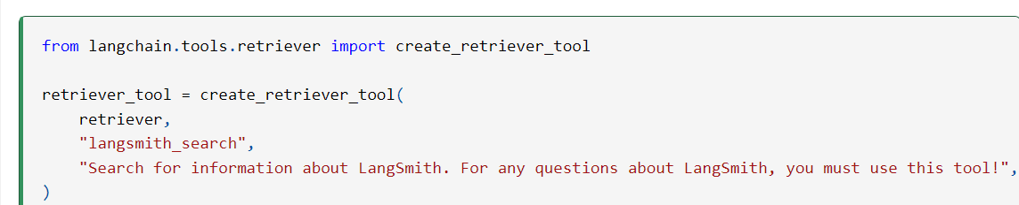

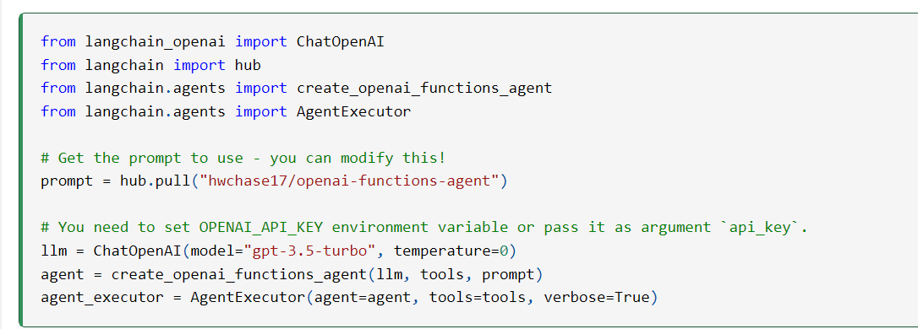

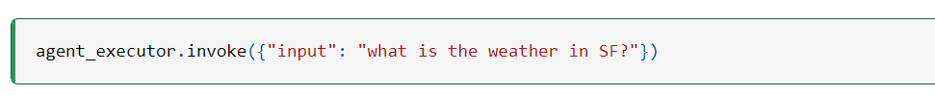

**Application of Agents**

In LangChain, agents have diverse and impactful applications. They can be employed in customer service to handle inquiries, provide support, and resolve issues efficiently, allowing human agents to focus on more complex matters. Personal assistants built with LangChain can help users manage their schedules, set reminders, and control smart devices, enhancing daily convenience. In healthcare, agents can assist with diagnosing conditions, managing patient records, and offering personalized health advice, thus improving patient care and operational efficiency. In finance, LangChain agents can automate trading, manage investments, and detect fraudulent activities, streamlining financial operations and safeguarding against fraud. Additionally, in education, these agents can tutor students, personalize learning experiences, and assist with homework, contributing to more effective and engaging educational environments.

**Chapter 3. API**

**3.1 Introduction to Cohere API**

The Cohere API provides powerful tools for natural language processing (NLP) tasks, including text generation, summarization, classification, and embedding generation. Cohere offers state-of-the-art language models that can be easily integrated into various applications to enhance their capabilities. The API is designed to be user-friendly, allowing developers to quickly implement advanced NLP functionalities without extensive expertise in machine learning or data science.

**Key Features:**

* High-Quality Language Models**:** Access to state-of-the-art models for various NLP tasks.
* Ease of Integration: Simple API endpoints for seamless integration into applications.
* Scalability: Designed to handle large-scale text processing with high performance.

**3.2 Embedding Generation**

Embedding generation is a crucial part of many NLP tasks, as it involves converting text data into numerical representations that capture the semantic meaning of the content. These embeddings can then be used for various purposes, such as text similarity, clustering, search, and classification. The Cohere API provides efficient methods for generating embeddings, ensuring high-quality and accurate representations of the input text.

Key Features:

* Semantic Representation**:** Capture the meaning of text in numerical form.
* Versatile Applications: Use embeddings for a wide range of NLP tasks.
* High Performance: Generate embeddings quickly and efficiently.

**3.3 Language Models**

Cohere's language models are designed to understand and generate human-like text based on the input provided. These models can be used for a variety of NLP tasks, such as text generation, summarization, question answering, and more. The Cohere API provides access to these models, allowing developers to incorporate advanced language capabilities into their applications.

**Key Features:**

* Text Generation: Create coherent and contextually relevant text based on input prompts.
* Summarization: Generate concise summaries of longer texts.
* Question Answering: Provide accurate answers to user queries based on context.

**3.4 API Integration**

Integrating the Cohere API into applications involves setting up API keys, configuring requests, and processing responses. The API endpoints are designed to be intuitive and easy to use, enabling developers to quickly add advanced NLP functionalities to their projects. Integration can be done using various programming languages, with Python being a popular choice due to its simplicity and rich ecosystem of NLP libraries.

**Key Steps:**

1. Set Up API Key: Obtain an API key from Cohere and set it up in your application.
2. Configure Requests: Use appropriate endpoints and parameters to make requests to the API.
3. Process Responses: Handle the responses returned by the API and integrate them into your application logic.

By integrating the Cohere API into applications, developers can leverage powerful language models and embedding generation capabilities to build sophisticated NLP systems that deliver high-quality and contextually relevant results.

**Chapter 4. Web Scraping**

**4.1 Introduction to Beautiful Soup**

Beautiful Soup is a Python library designed for web scraping purposes. It allows for the extraction of data from HTML and XML files, providing a variety of methods for navigating and searching the parse tree to find and retrieve specific content. Beautiful Soup is known for its ease of use and its ability to handle poorly structured HTML, making it a popular choice for web scraping tasks.

**Key Features:**

* Easy Navigation**:** Navigate the parse tree with ease using methods like .find(), .find_all(), and CSS selectors.
* Handles Bad HTML**:** Robustly parses and extracts data from poorly formatted HTML documents.
* Integration with Requests**:** Works seamlessly with the requests library to fetch web pages.

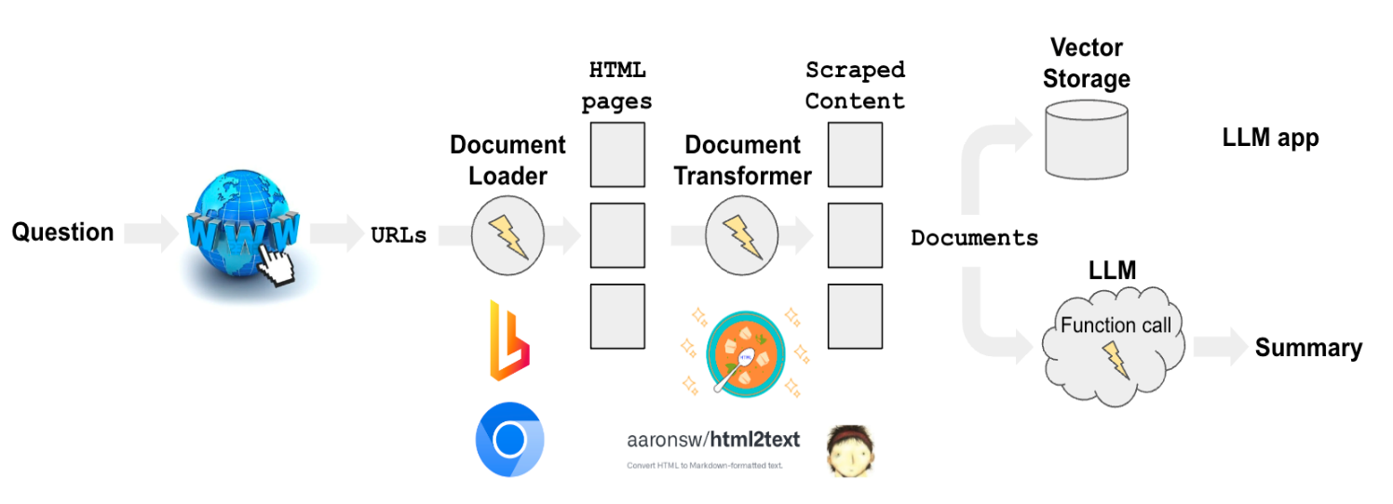

**4.2 HTML Parsing**

HTML parsing involves reading HTML content and converting it into a format that can be easily navigated and searched. Beautiful Soup creates a parse tree from the page's source code, which allows for the extraction of specific elements, attributes, and text content.

**Key Features:**

* Parse Tree Creation: Converts HTML into a tree structure that can be navigated and queried.
* Tag Search: Locate tags by name, attribute, or CSS selector.
* Text Extraction: Extract text content from HTML elements.

**4.3 Data Extraction**

Data extraction involves retrieving specific pieces of information from parsed HTML content. This can include extracting text, links, images, and other elements based on tags, attributes, or CSS selectors. Beautiful Soup provides various methods to locate and extract these elements efficiently.

**Key Features:**

* Text Extraction: Extract text from specific HTML tags.
* Attribute Retrieval: Retrieve attributes of HTML elements, such as href from <a> tags.
* Element Search: Use methods like .find(), .find_all(), and CSS selectors to locate elements.

**4.4 Integration with LangChain**

Integrating web scraping with LangChain involves using Beautiful Soup to extract text data from web pages and then feeding this data into the LangChain pipeline for further processing. This allows for the combination of web scraping capabilities with advanced NLP tasks, such as text analysis, summarization, and question answering.

**Key Steps:**

1. Fetch and Parse HTML: Use requests to fetch web pages and Beautiful Soup to parse HTML content.
2. Extract Relevant Data: Extract the necessary text and data elements from the parsed HTML.
3. Transform Data: Convert extracted HTML content into a format suitable for further NLP processing.
4. Feed Data into LangChain: Use the transformed data as input for the LangChain pipeline.

By integrating Beautiful Soup with LangChain, you can build robust NLP applications that leverage web-scraped data to provide meaningful insights and responses. This combination enhances the capabilities of your applications, enabling them to handle a wide range of text processing tasks efficiently.

**Chapter 5. Elasticsearch Database**

**5.1 Introduction to Elasticsearch**

Elasticsearch is a distributed, RESTful search and analytics engine capable of addressing a growing number of use cases. It is designed to store, search, and analyze large volumes of data quickly and in near real-time. Elasticsearch is often used for full-text search, log and event data analysis, and other types of complex data analysis. Its scalability and speed make it a popular choice for applications that require robust search capabilities.

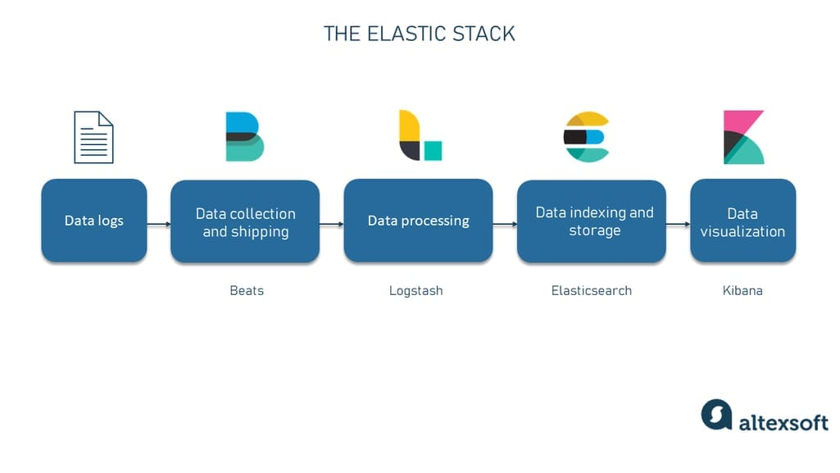

**Key Features:**

* Distributed Architecture: Scales horizontally to handle large volumes of data.
* Real-Time Search and Analytics**:** Provides near real-time search and data analysis.
* Full-Text Search: Supports powerful full-text search capabilities with flexible querying.

**Application of Elastic search**

Elasticsearch is widely used for its powerful and scalable search capabilities. It excels in full-text search applications, allowing users to quickly and efficiently retrieve relevant information from large datasets or document collections. This makes it invaluable for search engines, e-commerce platforms, and content management systems where fast and accurate search results are critical. Additionally, Elasticsearch is utilized in log and event data analysis, helping organizations monitor, analyze, and visualize operational data in real-time to identify issues and trends. Its capabilities also extend to real-time analytics, enabling businesses to perform complex queries and aggregations on large volumes of data, thereby supporting data-driven decision-making and insights. Overall, Elasticsearch enhances search functionality and data analysis across various industries, driving improved user experiences and operational efficiency.

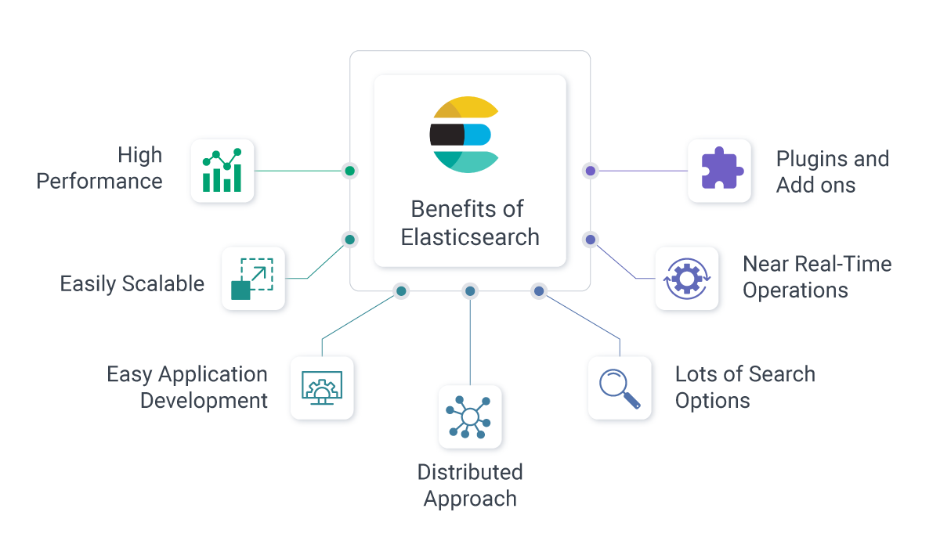

**5.2 Indexing Documents**

Indexing in Elasticsearch involves adding documents to an Elasticsearch index. An index is a collection of documents that have similar characteristics. Each document is a JSON object that contains data about a specific entity. When you index a document, Elasticsearch processes the data, creates an inverted index, and makes it searchable.

**Key Features:**

* Flexible Schema: Supports dynamic schema for storing JSON documents.
* Document Storage: Stores documents in an optimized format for quick search and retrieval.
* Indexing API: Provides RESTful APIs for indexing documents.

**5.3 Search and Retrieval**

Elasticsearch offers powerful search capabilities, allowing you to query indexed documents using a variety of methods. It supports full-text search, structured search, and filtering. You can perform simple keyword searches or construct complex queries to retrieve relevant documents.

**Key Features:**

* Query DSL: Use Elasticsearch's Query DSL (Domain Specific Language) to build complex queries.
* Full-Text Search**:** Perform searches on the content of documents using keywords, phrases, and Boolean operators.
* Filtering: Apply filters to narrow down search results based on specific criteria.

**5.3 Integration with LangChain**

Integrating Elasticsearch with LangChain allows you to enhance your NLP pipeline with powerful search capabilities. You can index documents processed by LangChain and perform searches to retrieve relevant data based on user queries. This integration enables efficient storage, search, and retrieval of large volumes of text data.

**Key Steps:**

1. Index Documents: Use LangChain to process and prepare documents, then index them in Elasticsearch.
2. Generate Embeddings: Use Cohere or another embeddings model to generate embeddings for the documents.
3. Store Embeddings**:** Store the generated embeddings in Elasticsearch for efficient similarity search.
4. Search and Retrieve: Use Elasticsearch's search capabilities to retrieve relevant documents based on user queries.

By integrating Elasticsearch with LangChain, you can build powerful NLP applications that combine the strengths of advanced language models and efficient search capabilities. This integration enhances the ability to process, store, and retrieve large volumes of text data, providing robust solutions for various use cases.

**Chapter 6. Final Project Overview**

**6.1 Project Description**

The final project is designed to create an intelligent application that interacts with web content, processes it, and responds to user queries. The system involves scraping content from websites, converting this content into a structured format, indexing it in a search engine, and generating meaningful responses based on user inputs. The goal is to build a robust pipeline that can efficiently handle web data and provide relevant information in response to specific queries.

Key Features:

* Web Scraping: Extracts textual content from web pages.
* Text Processing: Transforms and splits content into manageable chunks.
* Embedding Generation: Converts text into semantic vectors using a language model.
* Indexing and Search: Stores and retrieves content using Elasticsearch.
* Response Generation: Uses a language model to generate answers based on user queries.

**6.2 System Architecture**

1. Data Extraction Layer:
   * Web Scraping**:** Utilizes Beautiful Soup to parse HTML and extract plain text from web pages.
   * Transformation: Converts HTML content to plain text if necessary.
2. Data Transformation and Processing Layer:
   * Text Splitting: Breaks down large documents into smaller chunks using RecursiveCharacterTextSplitter.
   * Embedding Generation: Generates text embeddings using the Cohere API to capture semantic meaning.
3. Search and Retrieval Layer:
   * Indexing: Indexes text chunks and embeddings in Elasticsearch for efficient search and retrieval.
   * Search: Retrieves relevant documents based on user queries using Elasticsearch.
4. Query Handling Layer:
   * Prompt Creation: Defines how responses should be structured based on the context and user input.
   * Response Generation: Uses Cohere’s Chat API to generate responses from the context provided by the search results.

**CODE**

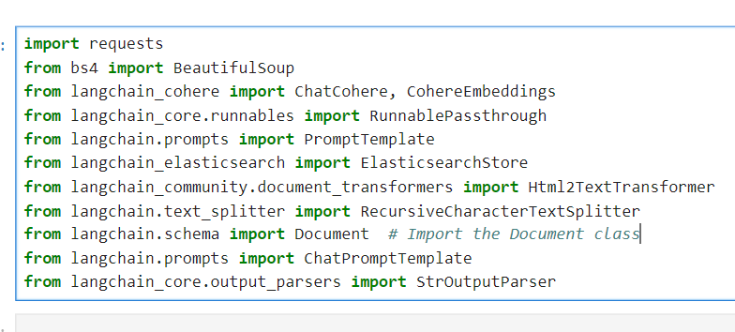

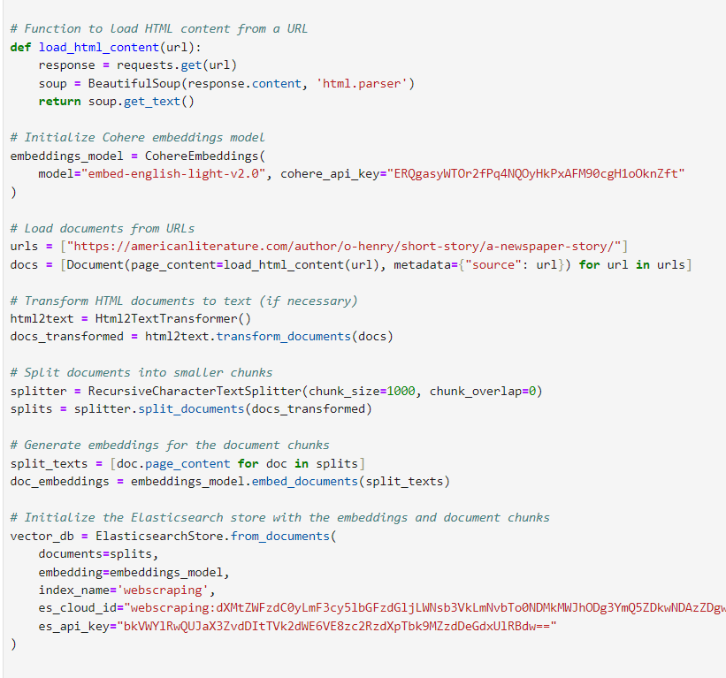

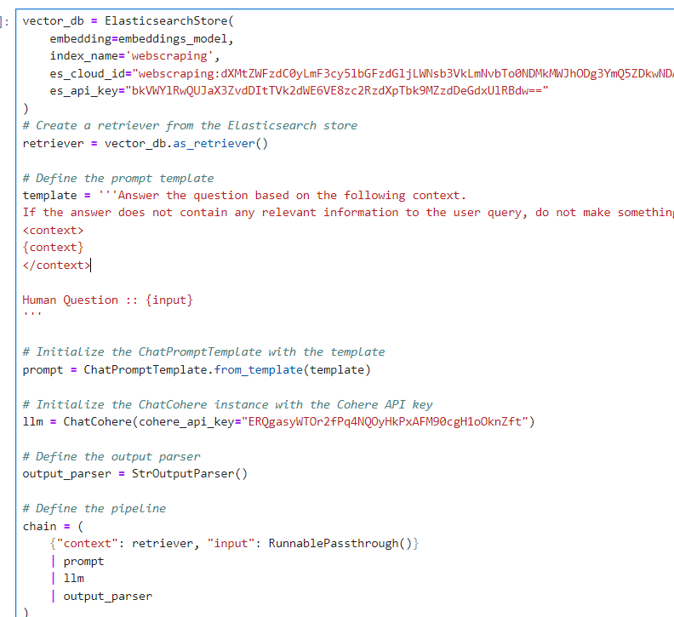

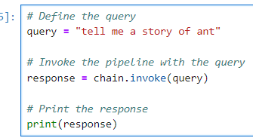

Output:

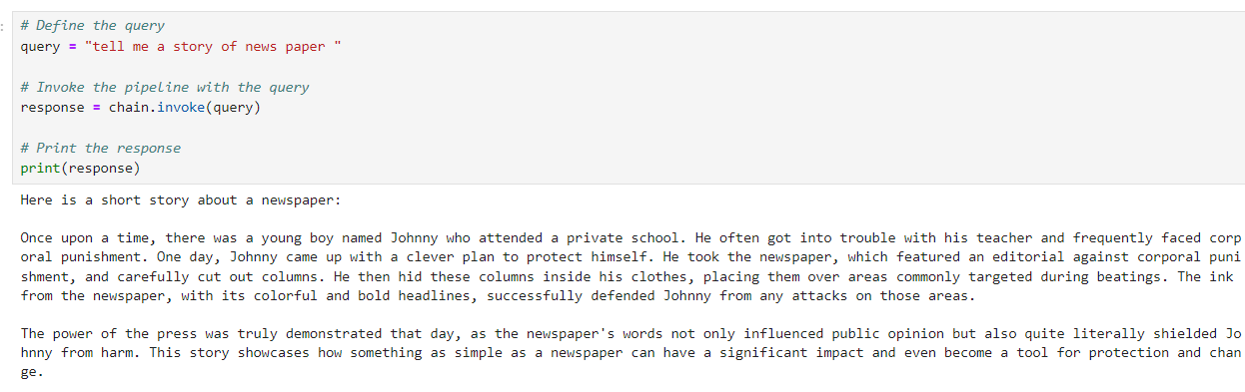

**Results and Observations**

* Content Extraction: The system successfully scraped and transformed web content into a usable format.
* Data Processing: Text was efficiently split and embedded, facilitating semantic analysis.
* Indexing and Search: Elasticsearch effectively indexed the content, enabling quick and relevant search results.
* Response Generation: The system generated meaningful responses to queries using the Cohere API.

**Observations:**

* Performance: The pipeline demonstrates good performance in data processing, indexing, and query handling.
* Accuracy: The integration of language models and search technologies ensures that responses are accurate and contextually relevant.
* Scalability: The system is scalable, allowing for the addition of more data and queries as needed.

Overall, the project provides a comprehensive solution for interacting with and analyzing web content, combining web scraping, NLP processing, and search capabilities into a unified application.

**Chapter 7. Path Forward and Future Enhancements**

**7.1 Summary of Learnings**

The final project has provided valuable insights into integrating various technologies to create an advanced web interaction system. Key learnings include:

1. LangChain Framework:
   * Understanding Pipelines: The project highlighted how to build and manage NLP pipelines using LangChain, including the use of LLMChain and Retrieval Chains to streamline text processing and retrieval tasks.
   * Prompt Templates and Output Parsers: Learning to create and utilize prompt templates and output parsers to refine responses and enhance the interaction between the language model and user queries.
2. Cohere API:
   * Embedding Generation: Gained experience with generating text embeddings using the Cohere API, which is crucial for transforming text into vectors that capture semantic meaning.
   * Language Model Integration: Applied Cohere’s language models to generate contextually relevant responses, demonstrating how to integrate powerful NLP capabilities into applications.
3. Beautiful Soup for Web Scraping:
   * HTML Parsing: Developed skills in using Beautiful Soup to parse and extract textual content from HTML documents, which is essential for web scraping tasks.
   * Data Extraction: Learned how to clean and transform web content into a format suitable for further processing and analysis.
4. Elasticsearch Database:
   * Indexing and Search: Acquired knowledge on indexing documents and performing search operations using Elasticsearch, which is key for managing and retrieving large datasets efficiently.
   * Integration: Experienced integrating Elasticsearch with other components of the system to facilitate quick and accurate search and retrieval of indexed data.
5. System Integration:
   * Combining Components: Gained insights into integrating multiple technologies (web scraping, text processing, embedding generation, search, and response generation) into a cohesive system capable of interacting with web content and answering queries.

**7.2 Future Work and Improvements**

1. Enhanced Data Sources:
   * Broader Web Scraping: Expand the system to handle a wider range of websites and content types. Implement additional scraping techniques to handle dynamic content, such as JavaScript-rendered pages.
2. Improved Query Handling:
   * Contextual Understanding: Enhance the system’s ability to understand and handle more complex queries by incorporating advanced NLP techniques and training the language model with more diverse datasets.
   * Multi-turn Conversations: Develop the capability to manage multi-turn conversations, allowing the system to maintain context across multiple interactions with users.
3. Performance Optimization:
   * Scalability: Optimize the system to handle larger volumes of data and queries more efficiently. Explore distributed computing or cloud-based solutions to scale up processing and indexing capabilities.
   * Speed: Improve response times by optimizing the Elasticsearch indexing and search processes, as well as refining the text embedding generation.
4. User Interface and Experience:
   * UI Development: Create a user-friendly interface for interacting with the system, providing a more intuitive and accessible way for users to input queries and view responses.
   * Feedback Mechanism: Implement a feedback mechanism to allow users to provide input on the accuracy and relevance of responses, which can be used to fine-tune the system further.
5. Additional Features:
   * Knowledge Base Integration: Integrate the system with external knowledge bases or databases to enrich the responses with additional information and context.
   * Customization: Provide options for users to customize the response style or focus areas based on their specific needs or preferences.

Overall, the project has demonstrated the potential of combining web scraping, NLP, and search technologies to build intelligent systems. Future work will focus on enhancing the system’s capabilities, scalability, and user experience to create a more robust and versatile tool for interacting with web content.

1. **CONCLUSION:**

This internship provided a valuable opportunity to work with advanced technologies and build a sophisticated natural language processing (NLP) system. Throughout the project, I gained hands-on experience with the LangChain framework, Cohere API, Beautiful Soup, and Elasticsearch, which allowed me to integrate web scraping, text processing, and search capabilities into a cohesive pipeline.

Key learnings included understanding how to build and manage NLP pipelines with LangChain, generating and utilizing text embeddings with the Cohere API, extracting and processing web data using Beautiful Soup, and efficiently indexing and retrieving data with Elasticsearch. The final project successfully demonstrated the integration of these technologies, resulting in a robust system capable of interacting with web content and generating meaningful responses to user queries.

Looking forward, there are several opportunities for further improvements, including enhancing the system’s ability to handle more complex queries, expanding its scalability, and developing a user-friendly interface. Overall, this internship has deepened my understanding of NLP technologies and their practical applications, preparing me for future challenges and opportunities in the field.

**REFERENCE LINKS:**

LANGCHAIN: <https://python.langchain.com/v0.1/docs/get_started/quickstart/>

COHERE API: <https://dashboard.cohere.com/welcome/login>

ELASTIC SEARCH: https://www.elastic.co/